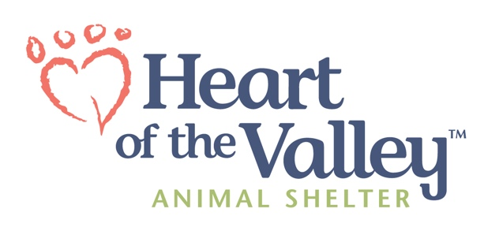
Interested in joining a dynamic team working to help people and pets in our community? Join the HOV team!
Job Title: Behavior Associate Department: Behavior
Status: Full-Time / Non-Exempt Pay Rate: $20.50/hr
Benefits Eligible: Yes Posting Created: March 17, 2025
Hours: 36 Hours/Week (8AM – 6PM Sunday – Wednesday Schedule)

Position Summary: Responsible for assisting the Behavior & Enrichment Manager (BEM) with the implementation of behavior assessments, behavior modification, daily enrichment, adoption and intake counseling for dogs and cats. Oversees the Canine Sleepover Program. The Behavior Associate works closely with animal care and vet clinic staff, as well as volunteers, and must act as part of a harmonious team. Additional duties will be assigned as needed to meet the needs of HOV at the discretion of the BEM or Operations Director. This position reports to the BEM.
Essential Duties & Responsibilities: To perform this job successfully, an individual must be able to perform each essential duty and task satisfactorily. Reasonable accommodations will be made to enable individuals with disabilities to perform the essential duties.
Behavior/Enrichment and Training Duties:
- Compile historical information for completion of adoption summaries for all fast-track dogs.
- Perform canine behavior evaluations in conformance with HOV policies and procedures under the guidance of the BEM.
- Ensure dog to dog introductions are completed in a timely manner; observe and/or oversee more complex introductions.
- Create and oversee dog play groups, ensuring appropriate selection of dogs.
- Organize group dog walks.
- Ensure behavior observations are recorded by staff using the Behavior Information Form protocol.
- Develop and implement behavior modification/enrichment plans using the Behavior Information Form protocol and communicate with staff regarding their role, if any, in the implementation of those plans.
- Communicate behavioral concerns and interventions to the BEM.
- Communicate health and welfare concerns to the BEM and/or vet clinic staff.
- Ensure behavior plans are being followed in cooperation and guidance of the BEM.
- Write bios for adoptable dogs and obtain quality images of adoptable dogs.
- Develop and implement individualized enrichment plans for all long stay animals under the guidance of the BEM.
- Oversee all aspects of the Canine Sleepover Program including selecting dogs that would benefit from the program and communicating/coordinating with sleepover volunteers.
- Perform behavior consults for HOV adopters and animals deemed “Behavior Consult.”
- Complete adoption callbacks on behavior consult dogs.
- Assist with behavior related surrender counseling, as needed.
- Perform initial medical exams for canines or felines with non-surgical requirements.
- Assist with daily animal care as needed.
- As needed, perform intake exams, and administer vaccines and parasite prevention to animals entering the shelter in accordance with HOV’s policies and procedures.
- In collaboration with the social media committee and Volunteer & Outreach Manager, develop creative ways to promote adoptable long stay animals.
- Maintain positive customer relations and public visibility, and act as a professional ambassador for all public interfaces in a manner upholding the mission and values of HOV.
- Work with the BEM to implement training programs for HOV staff.
- In conjunction with the Volunteer Manager and BEM, conduct training programs for HOV volunteers.
- Other duties as assigned.
Qualifications & Requirements: The requirements listed below are representative of the knowledge, skills, and ability required.
- Must have a minimum of 2 years’ experience in canine and feline behavior and safe animal handling.
- Must be able to work comfortably with dogs and cats of all breeds, ages, and temperaments.
- Must be able to write and communicate effectively with staff, volunteers, and members of the community.
- Must be able to work outdoors in all types of weather.
- Must be able to lift 50lbs.
- Must maintain an ongoing commitment to the mission, vision, policies and goals of HOV.
- Certified or in the process of obtaining Animal Behavior or Canine Training Certification (CTC, CCPDT-KA, CBCC-KA) preferred.
Special Machines, Tools, and Equipment Used: Power washer, industrial size washer/dryer, computers, standard office equipment, shelter vehicle.
To Apply: Visit our website at https://www.heartofthevalleyshelter.org/about-us/#Employment to complete our online application. To be considered as a candidate for this position, an online application must be submitted.
I understand this job description is intended to only provide an overview of the job responsibilities and requirements. It is not intended to be construed as an all-inclusive list of duties, skills, and abilities. Additional job duties and requirements may be assigned by supervisors as necessary. This job description does not represent an expressed or implied contract of employment, and Heart of the Valley reserves the right to change this job description and/or assign tasks as the needs of the organization dictate.

Signature: _____________________________________________
Date: _________________________________________________

