Animal’s Name _______________________Intake # ___________________Date ___________ Time ___________
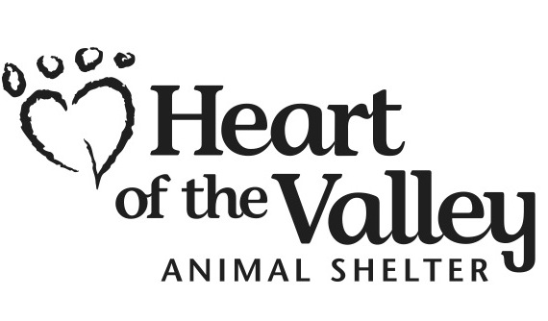 ADOPTION APPLICATION
Please print plainly. This application must be completed in its entirety.

Name _____________________________________________ Home Phone ____________________ Work _________________

Address ______________________________________ City __________________________ State ________ Zip ____________

Email Address ____________________________________________________________________________________________
I am aware that by declining to provide my e-mail address I forfeit my 30-day free 24PetWatch pet insurance gift.

How did you hear about Heart of the Valley? ___________________________________________________________________

Type of residence: House Condo Apartment Trailer Other (explain) __________________________________________

How long do you plan to live at this residence? ________________

Landlord’s Name _________________________________________________________Phone ___________________________

Number of adults in the home _________ Number and ages of children in the home ___________________________________

Have you adopted from us before? __________ If yes, when/ whom? _______________________________________________

How much do you plan to spend on your new pet in a one year span? _______________________________________________

How much one on one time do you plan spending with your pet each day? ___________________________________________

Do you have other pets? ___________ If yes, list number and type _________________________________________________

Are your pets spayed/neutered? ____________ Have you ever owned a cat, dog, rabbit before? _________________________

Why do you want this particular animal? ______________________________________________________________________

How will you correct your animal if it misbehaves? ______________________________________________________________

What behaviors do you find unacceptable in pets? _______________________________________________________________

For what reason would you surrender an animal? _______________________________________________________________

Do you have a completely fenced yard? ___________ What type? _______________________ How high __________________

Do you plan on declawing, removing dewclaws, or any other altering of your new pet? _________________________________

My activity level is: Low Medium High

What is the longest period your pet will be left alone? ____________________________________________________________

Are all members of your household in favor of adopting a pet? _____________________________________________________

Alternate Emergency contact for microchip registration (different person than the adopter):

Name______________________________________ Relationship ______________________ Phone ______________________

I understand that my pet has received a coupon for food from the Hill’s Science Diet “Food Shelter & Love” program, and that information about this adoption may be provided to Hill’s Pet Nutrition, Inc. for purposes of receiving post-adoption coupons and pet food offers. To opt out, initial here:

By signing below, I certify all the information I have provided herein is true and correct to the best of my knowledge. I understand that providing false or incomplete information may be grounds for my adoption to be denied. I understand that this Adoption Application is not a binding contract with Heart of the Valley, Inc. and that at any time I may be denied adoption at the discretion of Heart of the Valley, Inc. I further certify that I will be the primary caregiver of this pet.

Signature ____________________________________________ Date ____________________ Approved/Denied by _________

 | Notes | Done? | Initials
Dog Intro
Cat Test
Family Intro
Landlord check
ID check
PetPoint check
Medical evaluation disclosed
Behavior evaluation disclosed
Surrender history disclosed

Notes:

